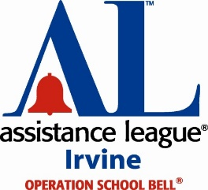
Your School Liaison is: Peggy Mariani
Liaison Contact email: peggymariani@icloud.com
Liaison Telephone number: 949-742-0295
Operation School Bell® School Contact Information

Assistance League® Irvine thanks you for agreeing to serve as School Contact for Operation School Bell (OSB), an important community service providing clothing and school supplies for income-qualified students in the Irvine Unified School District.

This year, we will again be clothing IUSD students from K – 12th Grade September through mid-October. There will be two ways to obtain an online OSB Application this year:

1. Families may go to our website (alirvine.org) for the application and complete it online
2. Families may go to their individual school website to click on the link to access the
OSB Application

Please Post on your school website/newsletter the following announcement:
2022-23 Operation School Bell® Program Announcement

Assistance League® of Irvine is starting our annual Operation School Bell Program (OSB), which provides new school clothes, shoes and backpacks to income-qualified IUSD families. OSB will be done in a safe environment following COVID protocols. The OSB online application will be posted Thursday, July 21, 2022 through Saturday, October 8, 2022.

To learn more about this program and fill out the online, fillable OSB Application, click Operation School Bell Application to access the Operation School Bell Application process:

Assistance League of Irvine
Operation School Bell
OSB@ALirvine.org
Procedures:

- Families complete application online. (Application is submitted directly to School Liaison)
- School Liaison will contact you to verify family’s enrollment in IUSD
- School Liaison will contact family to:
• make arrangements regarding requested financial documents
• set up a Meet & Greet appointment

Again, thank you for your vital role in Operation School Bell.

Assistance League Irvine
Operation School Bell Committee (OSB@alirvine.org )

