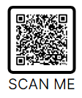**IUSD CHROMEBOOK INSURANCE PROGRAM**

**2024 Enrollment Window:  July 01, 2024 - September 30, 2024**

If you miss the initial enrollment window or check out a device later in the year, you can still purchase insurance for the 24/25 school year.  Late enrollments are not prorated and do not cover incidents of damage before the purchase.

IUSD is excited to continue our device insurance program for the 2024/2025 school year.  This year, we will be continuing device take-home programs for our middle schools.

**Parents have the option to purchase a $20 warranty from IUSD** **to cover accidental damage and theft**.  This is a one-time fee for the school year to cover potential incidents like cracked screens, missing keyboard keys, damaged plastics, liquid spills, and theft.  Funds raised from this program will be used to repair damaged devices, replace devices, and ensure our schools have enough devices to provide access to every student in IUSD.

Without insurance, typical repair costs for things like a broken screen or keyboard can range from $30-$75 depending on the model.  For excessive damage, our Chromebooks have a total replacement cost of $225.  Our goal is to ease parent concerns over damage to devices while in their child's care and continue to support a sustainable take-home program for our schools.

You can sign your student up for Chromebook Insurance at [MySchoolBucks.com.](http://www.myschoolbucks.com/)  You'll need to create an account and add in your student's information so we can associate the insurance with your child. Additional information regarding creating a MySchoolBucks account can be found at <https://support.iusd.org>

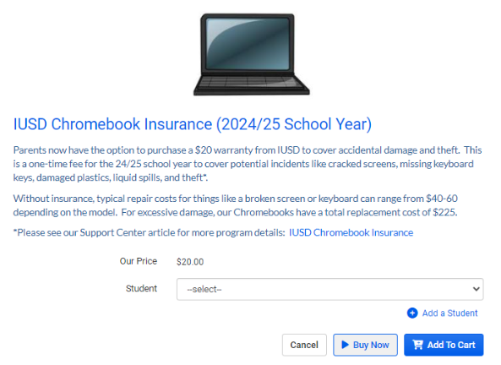

Direct link to IUSD Chromebook Insurance: https://bit.ly/IUSDChromebookInsurance24

# REPORTING A DAMAGED OR LOST CHROMEBOOK

* **Email**[**helpdesk@iusd.org**](mailto:helpdesk@iusd.org)**and provide the following information:**  
  + Student’s Name:
  + School:
  + Grade:
  + Student ID number:
  + Did you purchase insurance?: Yes/No  
     **If Damaged, include:**
  + A brief description of the damage
  + Please attach a photo of the damage (if possible)  
      
    **If Lost, include:**
  + A brief description of when/where the device was lost  
      
    **If Stolen, include:**
  + A brief description of when/where the device was lost and a**copy of the police report.**
  + **If needed, we can provide the device model and serial number for you to include in the police report.**
  + **A copy of the report will be required when reporting loss due to theft.**
* A technician from your school will respond with your next steps for exchanging the damaged device for a working one. They will inspect and repair the damage if possible, and you will be notified if any fines for repair or replacement will be assessed.
* If you purchased the [IUSD Chromebook Insurance,](https://support.iusd.org/hc/en-us/articles/360033840394-IUSD-Chromebook-Insurance-Program)there will be no charge for accidental damage or theft.

**Typical Chromebook Repair Costs**(without Insurance)

|  |  |
| --- | --- |
| **Damage** | **Cost** |
| Broken Screen | $35 |
| Keyboard (inc. missing keys) | $25 - $50 |
| Physical Damage - Plastic Case | $30 - $75 |
| Lost Charger | $25 - $35 |
| Full Replacement | $225 |

If you have any questions about the Insurance program, check with your school or email [helpdesk@iusd.org.](mailto:helpdesk@iusd.org)